World Cup Project

**Team Memebers**

* Mohamed Essam Abd Elmoneim
* Mahmoud Fahmy Emam
* Mahmoud Adel Ahmed
* Ziad Mohamed Badry
* Mennatullah Adel Mohamed
* Hana Nabil Ahmed

Contents

Description

System Classes

1. Group

2. City 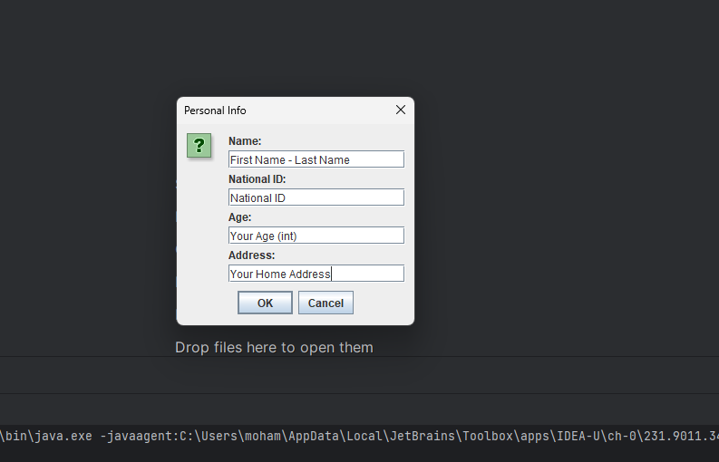

3. Match

4. Person

5. Ticket

UML

GUI

# Description

A football world cup ticket booking system designed in Java with a simple User Interface, allowing the audience to view the scheduled matches and their information then book a ticket.

# System Classes

## Group

Creates the groups of teams and generates the matches of the teams in each group

## City

## Match

Generates the match details

## Person

Display the details about the audience of the match

## Ticket

Responsible for booking a ticket

# UML

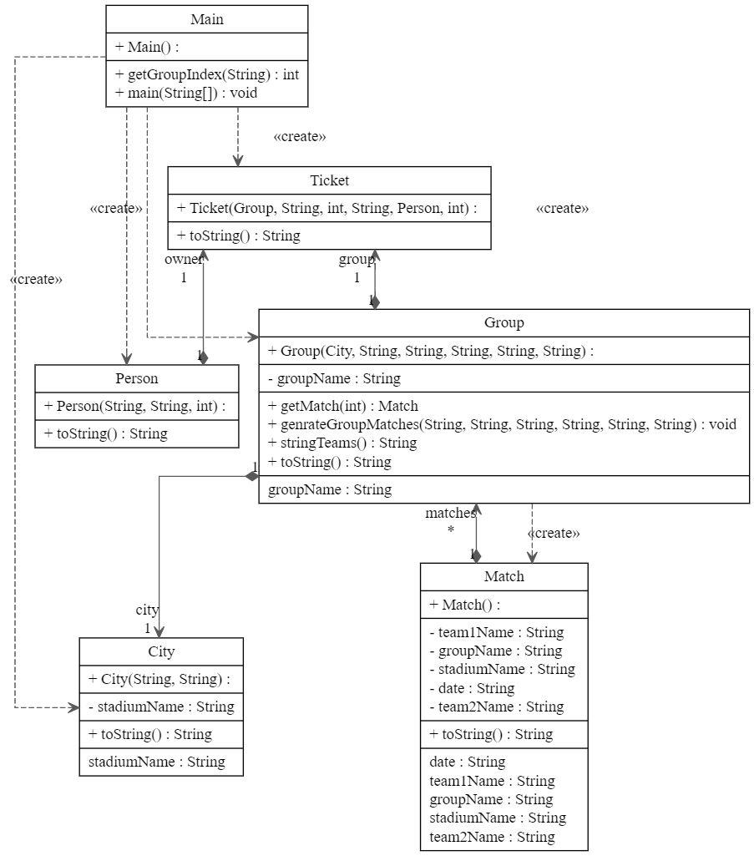

# GUI

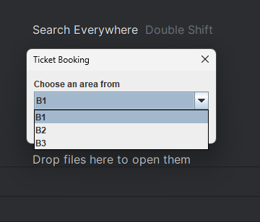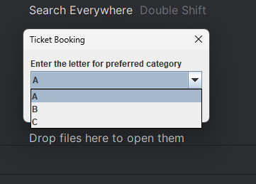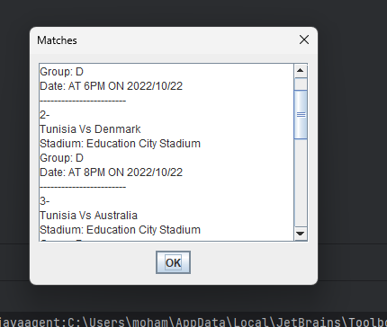

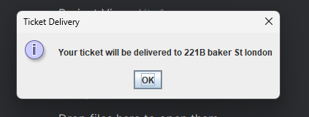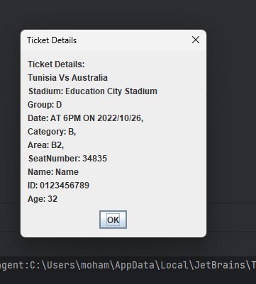

Identification of System Objects for FIFA World Cup Ticketing System

Introduction:

The FIFA World Cup Ticketing System is designed to facilitate the organization and distribution of match tickets for the upcoming tournament. This report aims to identify the system objects involved in the ticketing process, including the entities, their attributes, and their relationships.

Entities:

1.1 Cities (C1-C8):

Represents the eight different cities where the World Cup matches will be organized.

1.2 Stadiums (S1-S8):

Represents the eight different stadiums where the matches will take place.

Each stadium is associated with a specific city.

1.3 Participating Teams (T1-T32):

Represents the thirty-two teams participating in the World Cup.

Each team is associated with a group and plays matches in a specific stadium.

1.4 Groups (G1-G8):

Represents the eight groups into which the teams are divided.

Each group consists of four teams.

Matches within each group are played in a designated stadium.

1.5 Matches:

Represents the individual matches played during the World Cup.

Each match is associated with a stadium, a group, and two teams.

Contains information about the date, time, and other details of the match.

1.6 Tickets:

Represents the match tickets available for purchase.

Each ticket is associated with a specific match, stadium, and ticket category.

Contains information about the seat number, ticket owner details, and price.

1.7 Ticket Categories:

Represents the different categories of tickets available for purchase.

Includes Category 1, Category 2, and Category 3, with varying prices and seating areas.

1.8 Areas (A, B1-B3, C1-C2):

Represents the different areas within a stadium where seats are located.

Category 1 tickets are in prime areas (Area A), while Category 2 and Category 3 tickets are in different sections (B and C).

1.9 Ticket Owners:

Represents individuals who purchase tickets.

Contains information about the ticket owner's name, national number, age, and address.

Relationships:

2.1 City-Stadium Relationship:

Each stadium is associated with a specific city.

Enables identification of the stadium's location.

2.2 Team-Group Relationship:

Each team is associated with a specific group.

Allows teams to be grouped together for the matches.

2.3 Team-Stadium Relationship:

Each team is associated with a specific stadium.

Enables allocation of matches to stadiums based on the participating teams.

2.4 Group-Stadium Relationship:

Each group is associated with a specific stadium.

Determines the stadium where the group matches will be played.

2.5 Match-Stadium Relationship:

Each match is associated with a specific stadium.

Allows identification of the stadium where a particular match will be held.

2.6 Match-Group Relationship:

Each match is associated with a specific group.

Enables allocation of matches to the respective groups.

2.7 Match-Team Relationship:

Each match involves two teams.

Identifies the participating teams for each match.

2.8 Ticket-Match Relationship:

Each ticket is associated with a specific match.

Enables identification of the match for which the ticket is purchased.

2.9 Ticket-Ticket Category Relationship:

Each ticket is associated with a specific ticket category.

Determines the price and seating area for the ticket.

2.10 Ticket-Ticket Owner Relationship:

Each ticket is associated with a specific ticket owner.

Facilitates the delivery of tickets to the ticket owners.

Conclusion:

The FIFA World Cup Ticketing System involves various entities and their relationships to manage the distribution of match tickets. The identified system objects include cities, stadiums,